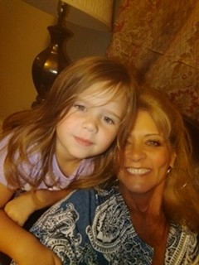

Angie Cobble’s One Page Profile

Workforce Development Specialist

Report to: Program Coordinator

**Go to person for:**

* Applications, on boarding new hires, New Hire orientation, CPr/fa, CPI, POM, PCT, training schedules, pom interviews
* On call duties
* Fire putter-outter

**What’s important to me………………………………………..**

* Teamwork
* Having fun
* Doing a good job
* Meeting the needs of the people I support
* People supported living the life they chose to the best of their ability
* People supported exercising their rights
* Getting my work done in a timely manner
* Spending quality time with the people I support
* Separating work life from personal life

**How to support me well at work………………..**

* **Encouragement when feeling overwhelmed**
* **Working as a team**
* **Be Person Centered**
* **Have fun ☺**
* **Be respectful of everyone…the people supported, co-workers, families, etc**
* **Allow me to ask a lot of questions…because I will**
* **Keeping me informed and being flexible with what’s going on**

***What People Like and Admire About Me!***

* Believes in teamwork
* Funny
* Flexible
* Friendly
* Organized
* Kind
* Honest
* Person Centered