**Lynne and Nolda’s Co-Mentor Trainer Profile**

**Mentor Trainers in Person Centred Thinking, Essential Lifestyle Planning and Person Centred Coaches**

**Certified through the Learning Community for Person Centred Practices**

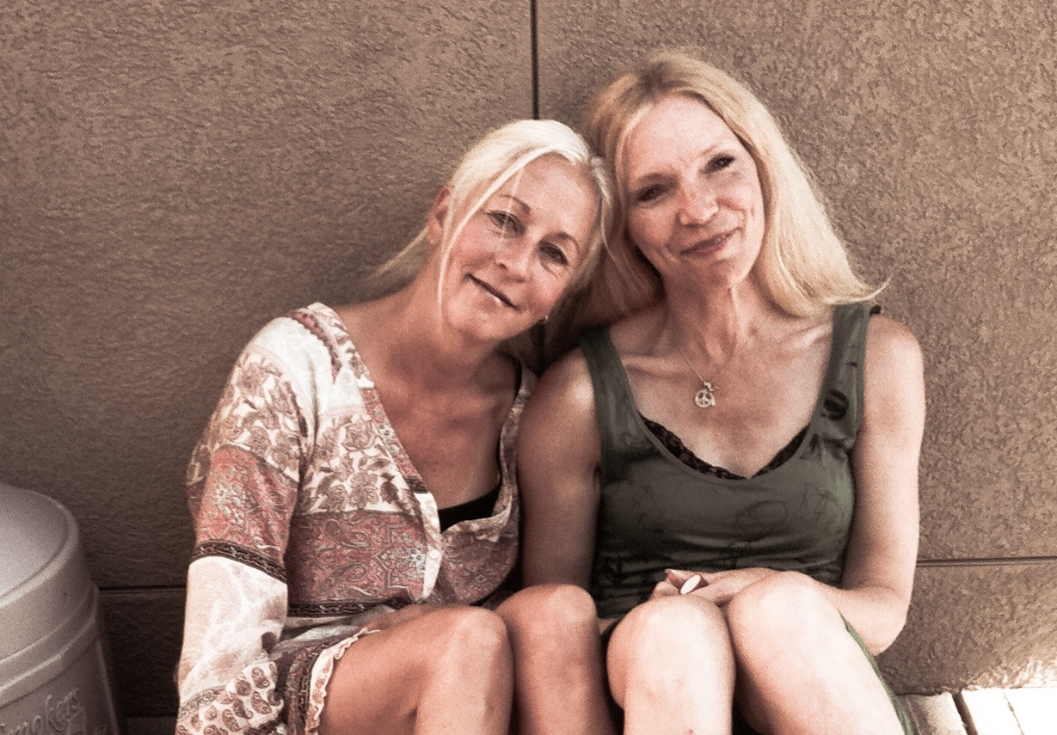

**Nice things said about Nolda…**

* Passionate, open, creative and fun.
* Flexible and open minded.
* Mindful, thoughtful and kind hearted.
* Encouraging and supportive.

**Nice things said about Lynne…**

* Passionate, fun, laid back and welcoming.
* Knows her stuff!
* An experienced natural presenter.
* Enthusiastic and great energy.
* A great coach and teacher.

**What’s Important to us as a team…**

* That we mentor and train together.
* That individual learning styles and personalities are honoured.
* Hearing stories.
* That people have fun while learning.

**How to best support Nolda…**

* I prefer to train and mentor with Lynne.
* I need time to prepare and stay organized.
* That I have opportunities to draw and use colours.
* Let me know how I can best support you – ask for help or clarification – be honest and open.
* Share your creativity and ideas. Ask questions. Encourage the passion.
* Ask for follow up support if you want and need it. Help keep the learning alive.
* Give me valuable feedback for growth and development as a mentor and trainer.

**How to best support Lynne…**

* I prefer to train and mentor with Nolda.
* Support me with technology.
* To have continuing opportunities to grow and learn.
* Use evaluations to improve and enhance me as a mentor and as a trainer.
* Be open and honest.
* Ask questions – encourage discussion. Talk about the tough stuff.

**What’s Important to Lynne as a Mentor Trainer…**

* That people feel safe and relaxed.
* Flexibility according to the learners…while avoiding drift.
* To make time for discussion – hear the people.
* That we learn from one another.
* To give people things to think about…so they can take it away and be creative.
* To encourage people to think deeper while celebrating what they already do.

**What’s Important to Nolda as a Mentor Trainer…**

* Celebrating successes. That people take away what they learn – and make a difference in someone’s life.
* Learners learn – they leave thinking…wondering…pondering…interested and excited.
* To learn from others. To listen to others.
* To be organized and prepared.
* Be honest and open about what support you need from me.