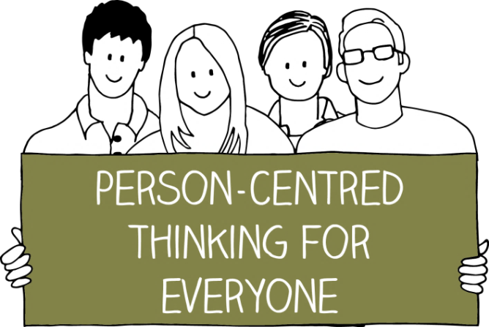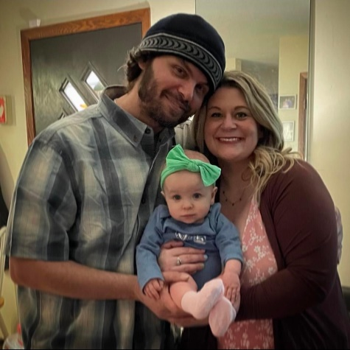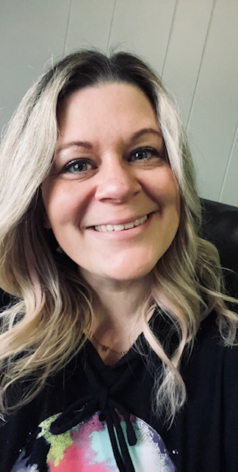

***What’s Important TO me***

* ***Trainers feel supported, and get the most out of their learning and facilitating experience***
* ***Connection: learn how we can learn and communicate best with one another***
* ***Trainers are open with me: Letting me know when something isn’t clear or have questions, so I can support you in your learning***
* ***Seeing others learn, develop & be successful***
* ***Having a sense of pride in what I do & making***

***a different***

* ***Having the resources I need to train and coach successfully***

***How to best support me***

* **Share with me how you learn and communicate best, including how/when you like to receive feedback**
* **Tell me how best to support you, its important to me to adapt to the stYle that works for you**
* **I appreciate deadlines along your process: please tell me what you hope to accomplish and by when**
* **Follow through with the plan (Do what you agreed to do) or give me & explanation of why it cant be done**
* **Listen attentively when I share with you what I think, suggestion, etc.**
* **If something is not clear, ask me to clarify or to provide you with more information.**
* **Be open to my ideas to enrich training material/content & Facilitation within the PCT curriculum**
* **Share your ideas, examples, etc of how you use the tools or outcomes of using them**

**Like and Admire about me**

* **Great sense of humor**
* **Approachable, supportive & takes the time to listen**
* **Flexible & adaptable to in teaching/ coaching various learning styles**
* **Don’t judge- meet the person where they are at in their learning/experience**
* **Creative in teaching & communicating ideas**
* **A lot of personal stories and examples related to PCT to share**

**Brittany Sliger Wood**

**Mentor Trainer**