Alva Gardner

Trainer One Page Description

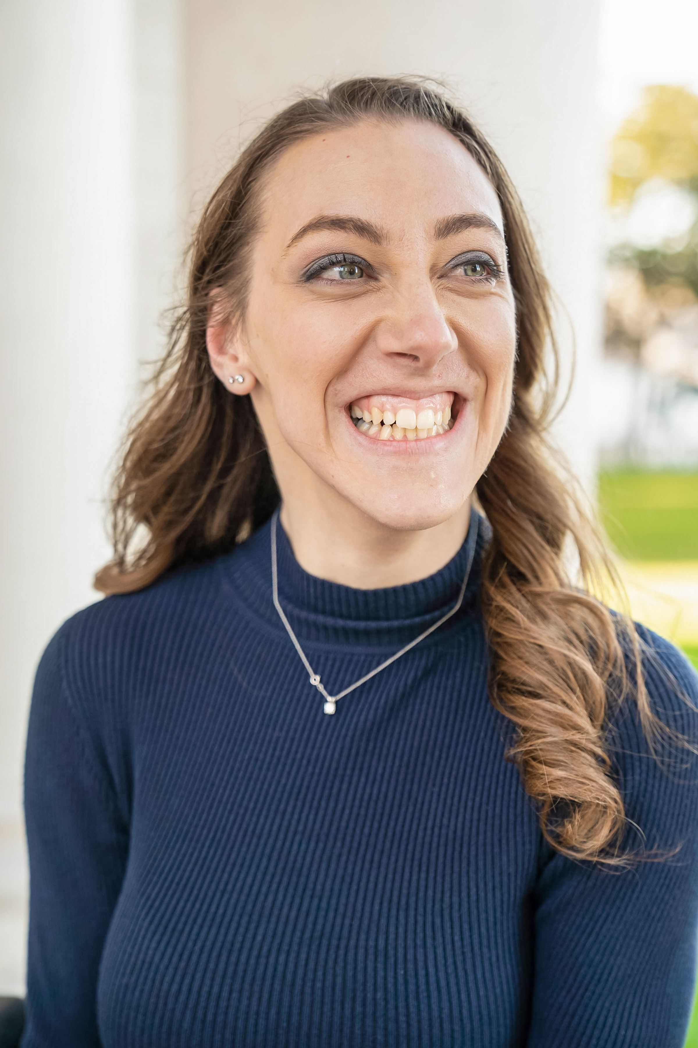

What people like and admire about me as a trainer

*Outgoing*

*Smart*

*Knowledgeable in her work*

*Compassionate*

*Go-Getter*

*Easy to get along with*

*Witty*

*Funny*

*Advocates for herself and others*

*Friendly*

*Strong-Willed*

*Good listener*

*Good problem-solver*

*Gives good advice*

*Personable and Relatable*

*Adaptable*

What is important to me as a trainer

- To raise awareness of the full capabilities of people with disabilities

- To teach others an empowering way of supporting people with disabilities

- To maintain a positive work/life balance

- That I have the equipment and technology required to allow me to be as independent as possible

- That the room I’m training in be accessible and facilitate my independence

- To be able to rely on my partner during a training

- To let my personal experiences and knowledge show in my trainings and related work

- To be very genuine with the people I'm training and my training partner

- That participants in my trainings learn new things, enjoy the training experience, and have fun during our time together

- To represent the amazing work that is possible in disability services

How to best support me as a trainer

- Show up ready to participate and learn new skills both days of the training

- Please try to keep an open mind on how PCT applies to all aspects of your life

- Please stop me and ask questions, if I don’t know the answer I will do my best to find them

- Please let me know if you didn’t understand something I said, because of my speech

- Please be prompt when returning from breaks

- If you need to use your phone please feel free to leave the room

- Misery is optional, please let me know if I can make you more comfortable

- If you want to share stories with me, please share them during break times

- If you would like support or advice after the trainings, please email me! I would love to help you strengthen your skills after the training is over

- Have a friendly, mutual interaction and working relationship with me when possible