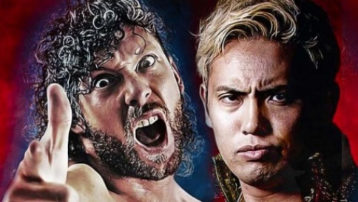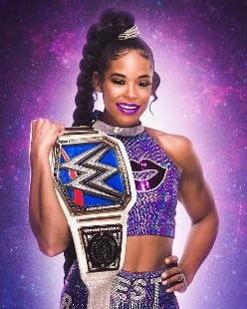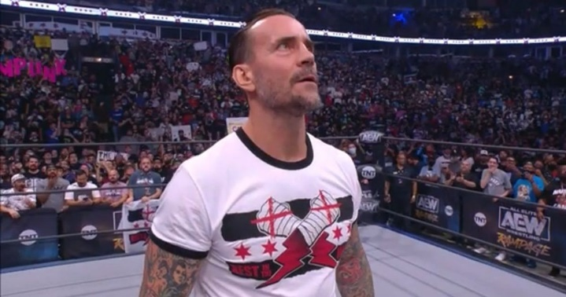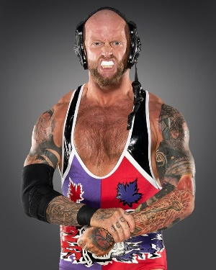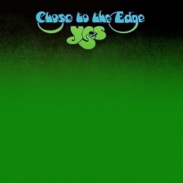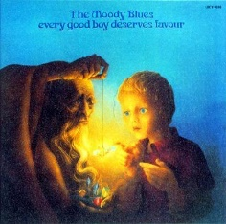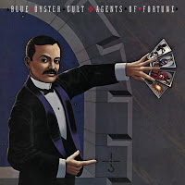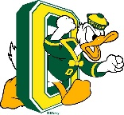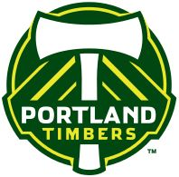

**How To Best Support Kirk**

* Spoken information is hard for me to remember, especially if there are a lot of details. Give me important information in WRITTEN form, especially instructions and lists.
* It took me most of my life to become comfortable in my own skin. If I absolutely must get out of my comfort zone, let me do it on my own terms.
* As calm and centered as I might seem, I do have an anxiety disorder and I may need you to talk me down. Humor helps, but may not be enough.
* Show me the big picture, and how my role and my work fit in it.
* Small talk doesn’t come naturally to me; be comfortable with my silence.
* Give me time and space to be creative.
* I am a harsh self-critic. The more (and more vaguely) you praise me, the less I will believe what you say. A mild complement on something very specific will do just fine. I find constructive feedback much more useful.
* I like to work independently, but that can be a trap when I have a big job to do. Offer to help when you think I’m overwhelmed, and remind me to delegate tasks.

**Good match characteristics**

**Present:**

* “Zen masters”; people who are calm and insightful
* People who are good at reading people
* People who are intelligent and curious
* Connoisseurs of music
* Pro wrestling fans

**Absent:**

* People-fixers
* High-energy extroverts
* People who think that “extrovert” = “normal”
* People who draw too much attention to me
* Conversation hijackers
* “Squirrel chasers”

**What is Important TO Kirk**

* Having a predictable schedule and control over my spare time; I used to work two jobs, and may again someday
* Looking for ways to understand my anxiety, recognize the symptoms, avoid triggers, and manage situations that might make me anxious, so that I do not need medication
* Having control over my work environment to manage stress and anxiety; this includes a supply of snacks, music, fidgets, and fun objects on my desk
* Expanding my comfort zone
* Knowing what other people expect of me
* Being creative and finding ways to express myself and put my own personal stamp on a project
* Having a sense of purpose, feeling like a part of something bigger than myself, having work that contributes to a cause
* Holistic understanding, seeing the big picture
* Having time to recover after intense interactions or being in the spotlight
* Having room in my life for the things that help me recharge, especially books, music, professional wrestling

***Kirk’s One-Page Trainer Description***

**What People Like and Admire about Kirk**

* Calm and mostly unflappable
* A good teacher
* Takes time to reflect
* Understanding
* Doesn’t like to criticize
* Has a good voice
* Concerned about gathering facts
* Generous
* Creative
* Team player
* Respects others’ perspectives
* Wicked sense of humor
* Nice shirt!