Lesley's one page description as a PCT Trainer

What is Important to me
at work and as a Trainer:
- Being given the opportunity to try new things, develop professionally

- Honest feedback given in a respectful way that raises my awareness, promotes growth and learning

- Give me room to explore ideas within parameters of agency need

- Provide me opportunity to learn from others

- Tell you “just need the tree!” or be upfront about scope of discussion, meeting, etc – “rein me in!” if needed

- Kindly let me know if my exuberance is exhausting you

- Give me opportunities to share and promote the development of others

Challenges:
- Tend to give too much detail, explanation

- Can get off on a tangent easily

- My energy is sometimes distracting, and “tiresome”

- How did I run out of time again?

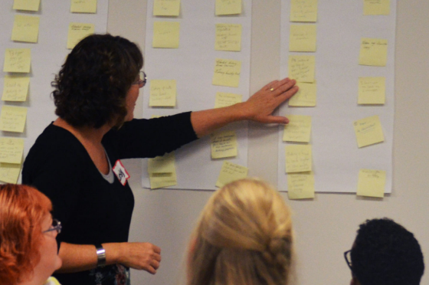

What others say they like and appreciate about my style:
- Creative, innovative - seeks and finds new ways to present material

- High energy level, enthusiastic

- Focused on creating a positive experience for audience

- Uses graphics, visuals, props, activities to enhance presentation

- Engaging, warm, entertaining

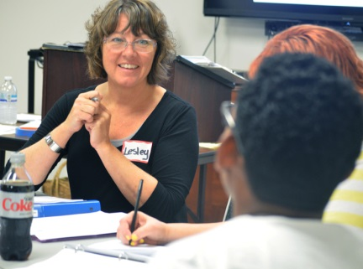
- Not afraid to take on tough questions or dynamics

How others can best support, encourage and assist me:
- Assist with technology – it is not my strong point!

- Be willing to let me try new approaches

- Be available for check in during trainings – for feedback, to help stay on track and timeframe, to adjust “the plan” as needed

- Assist with room set up, creation of materials, ordering supplies

- Provide honest, constructive feedback so I can improve

Strategies That Work For Me:
- Prepare visuals and graphics ahead of time

- Take notes during and reflect immediately after so I do not forget ideas that came up for activities, adjustments, etc

- Practice parts of presentation that I tend to go overtime on, or stumble over

- Know my audience prior so can prepare meaningful examples, activities

- Customize examples and activities to our work
Lesley Blecharczyk, 2022

