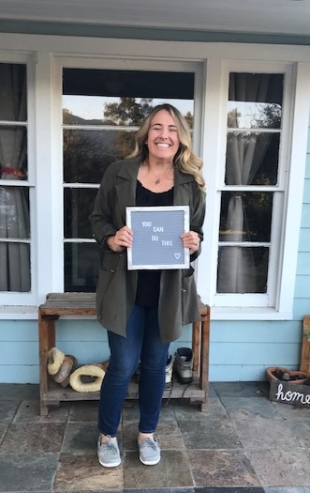

PCT Trainer Candidate One Page Profile

**Jessica Chauvel**



What is important to me as a PCT Trainer Candidate?

* To maintain open communication with my presenting team through text, IM, or email to ensure all is running smoothly.
* It is important to me to feel prepared before scheduled trainings by reviewing logistics, roles, and responsibilities ahead of time.
* I appreciate receiving constructive feedback regarding the way I deliver or prepare for a training, it helps me to continue to learn and improve.
* I value and enjoy being given new responsibilities like managing break out rooms, or delivering material.
* I enjoy leading, and setting the tone for meetings in a positive way. I like to do this through music, or by asking fun questions through out the training to engage attendee’s.
* It is important to me to work with positive people, who are eager to make things better.

**How PCT Trainers can support me as I become a PCT Trainer…**

* Guidance while learning my roles and responsibilities through clear communication will help me to establish a good foundation.
* When assigning me a task or project, I appreciate being given dated deadlines so I can complete the project in a timely fashion.
* Remind me to take my time on projects and “to work slow to go fast”.
* Share feedback or constructive guidance openly and honestly through verbal communication.
* Maintain a solution based mindset, and show up ready to be positive. This helps me to feel confident and focused.
* Allow me to process information after a meeting and develop follow up questions to be sure I am clear of expectations and my role.
* Please celebrate small victories with me as I enjoy celebrating others accomplishments as well as my own.
* Help me to not be so hard on myself and reflect on my successes.
* Be willing to be silly with me and joke. I enjoy being friends with my colleagues, and hope to build strong relationships with my team mates.
* I am a tactile and visual learner. When supporting me please encourage me to take my own notes, and practice delivering presentations/trainings.

## What people like and admire about me as a PCT Trainer…

* I am positive and energetic.
* I am supportive and always willing to offer a helping hand.
* I am a “yes person” and will offer support when needed.
* I am a “go getter” and will try new things.
* I am organized.
* I am prepared, and react calmly when things don’t go as planned.

